How to Setup SSIS Scale Out 2022 Home Lab in VMware workstation

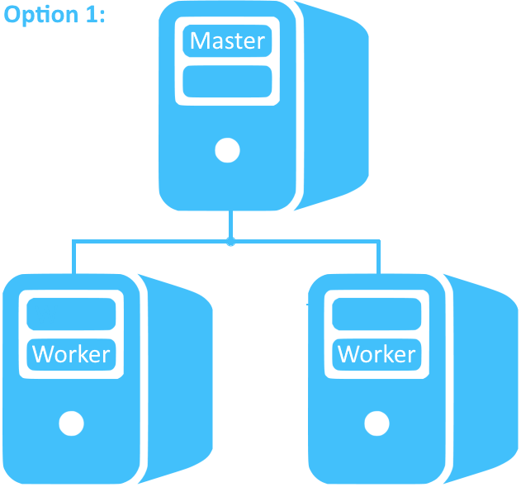 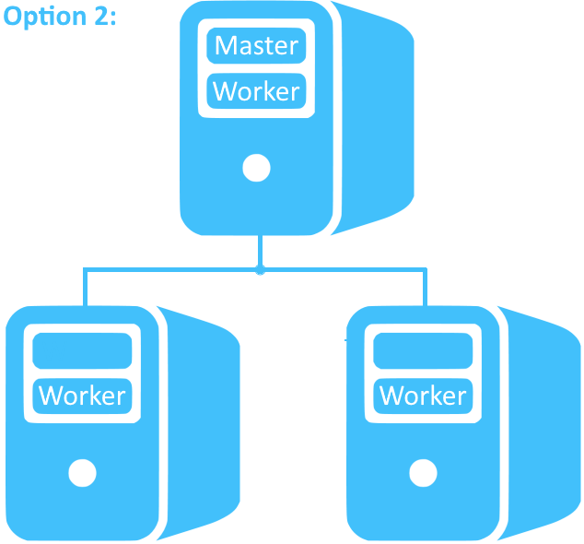

Step By Step:

1.In this demo, I am going with Option 1.

•Node 1 as a master.

•Node 2 & Node 3 as workers.

2.Install integration services along with Scale Out Master on Node1

3.Copy the Scale Out Master certificate from Scale Out Master (Node 1) to all worker nodes [Node2 & Node3]

Note: You can find this certificate in the installation directory.  
In your case, the installation path may vary:   
C:\ProgramFiles\Microsoft SQL Server\160\DTS\Binn\SSISScaleOutMaster.cer

4.Install integration services along with Scale Out worker on Node1 & Node2.

5.Copy the Scale Out worker certificate from both workers (Node2 & Node3) to the master (Node1).

6.Install both worker certificates on the master.

7.Create SSIS DB catalog on the master and select the "Enable this server as scale-out master" option.

8.Select "Manage scale-out" and add workers.

9.Deploy the sample package and run it in scale-out worker mode. Verify the results.

Note:Please enable sa authnetication for master node. And also keep same account to avoid issues further.